**인공지능**

**HW1**

소프트웨어학부

20163231

신승은

(1)

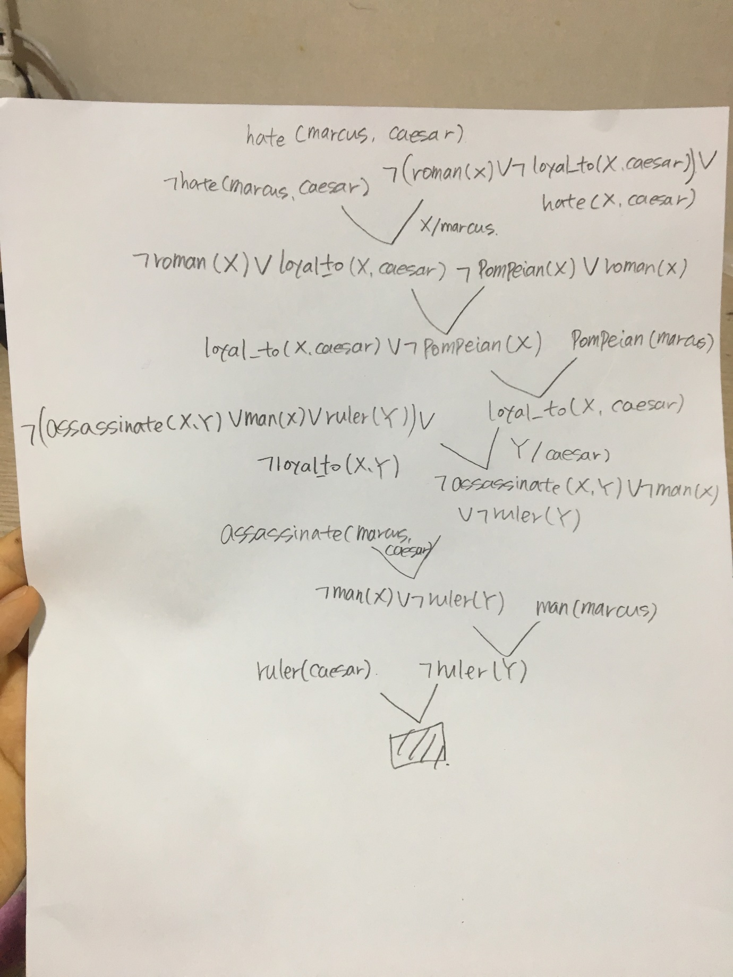



(2)

Q1.Marcus hated Caesar

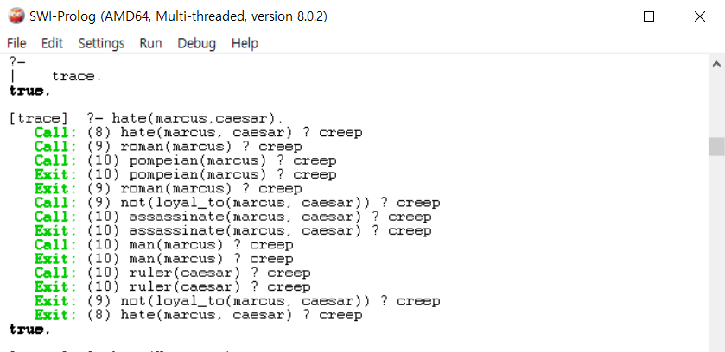

Q2.who hated Caesar?

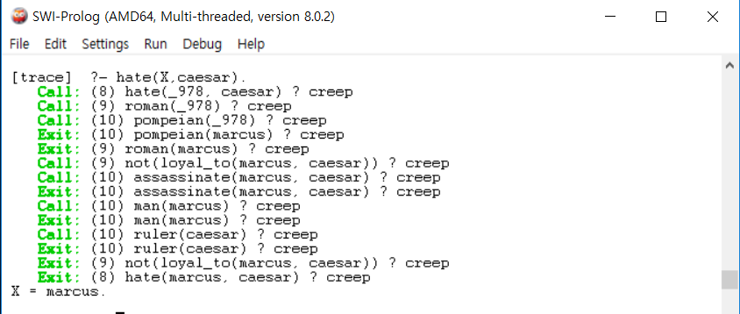

Source code

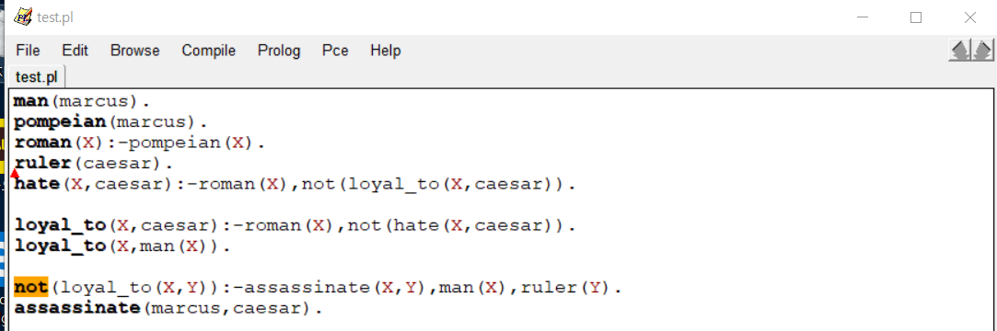

(3)

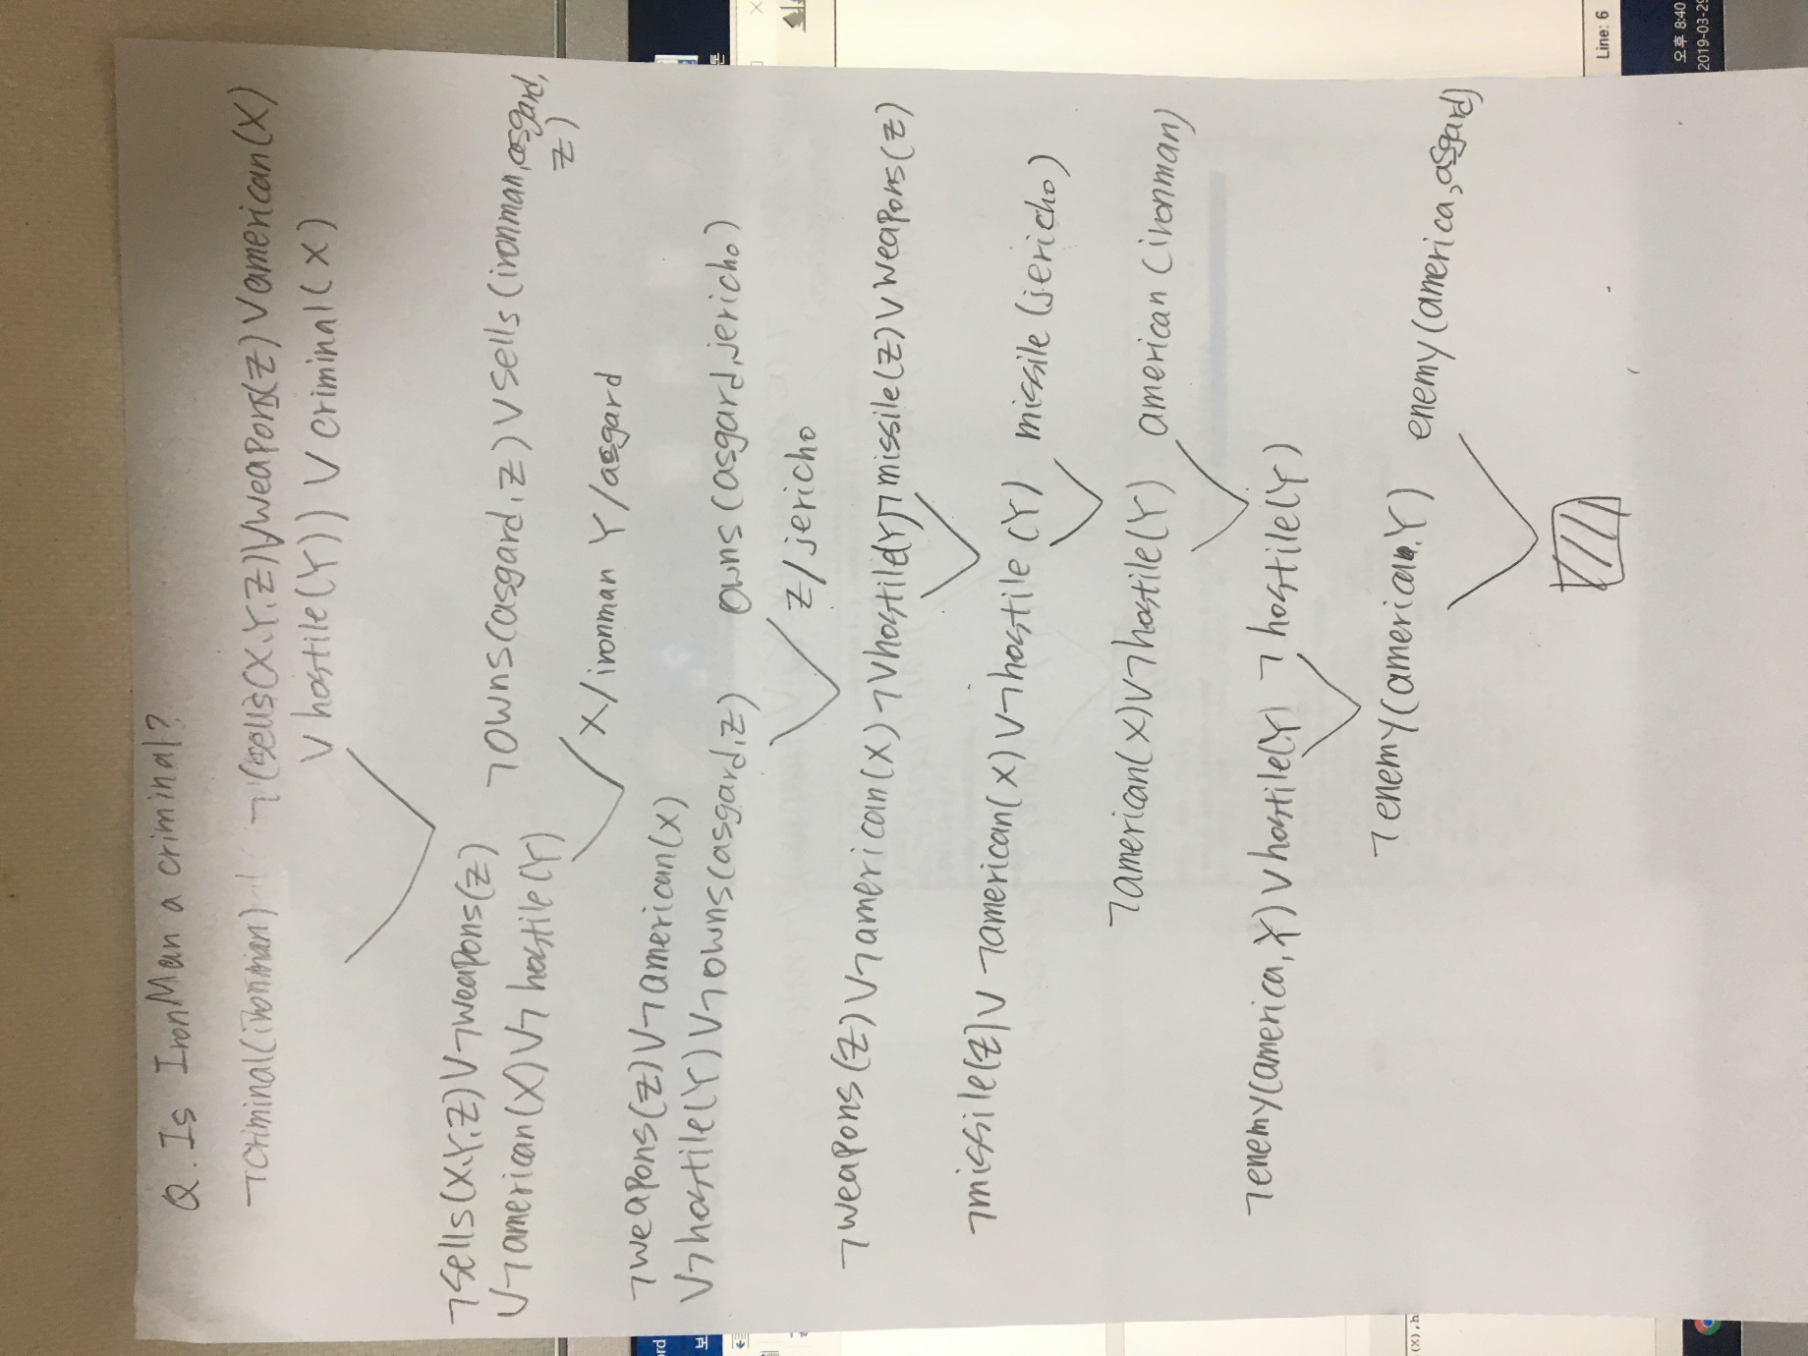



(4)

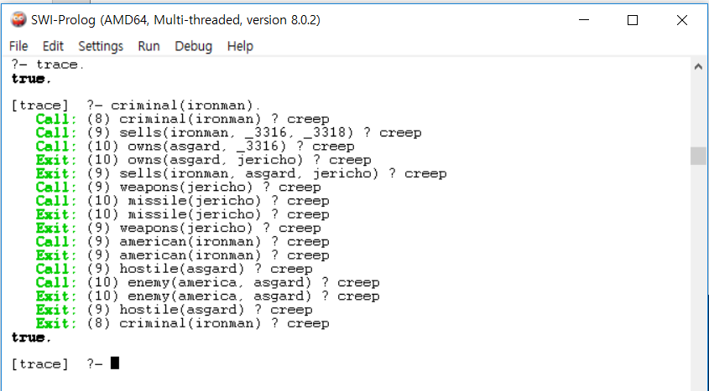

Source code

